Reflexology and Reiki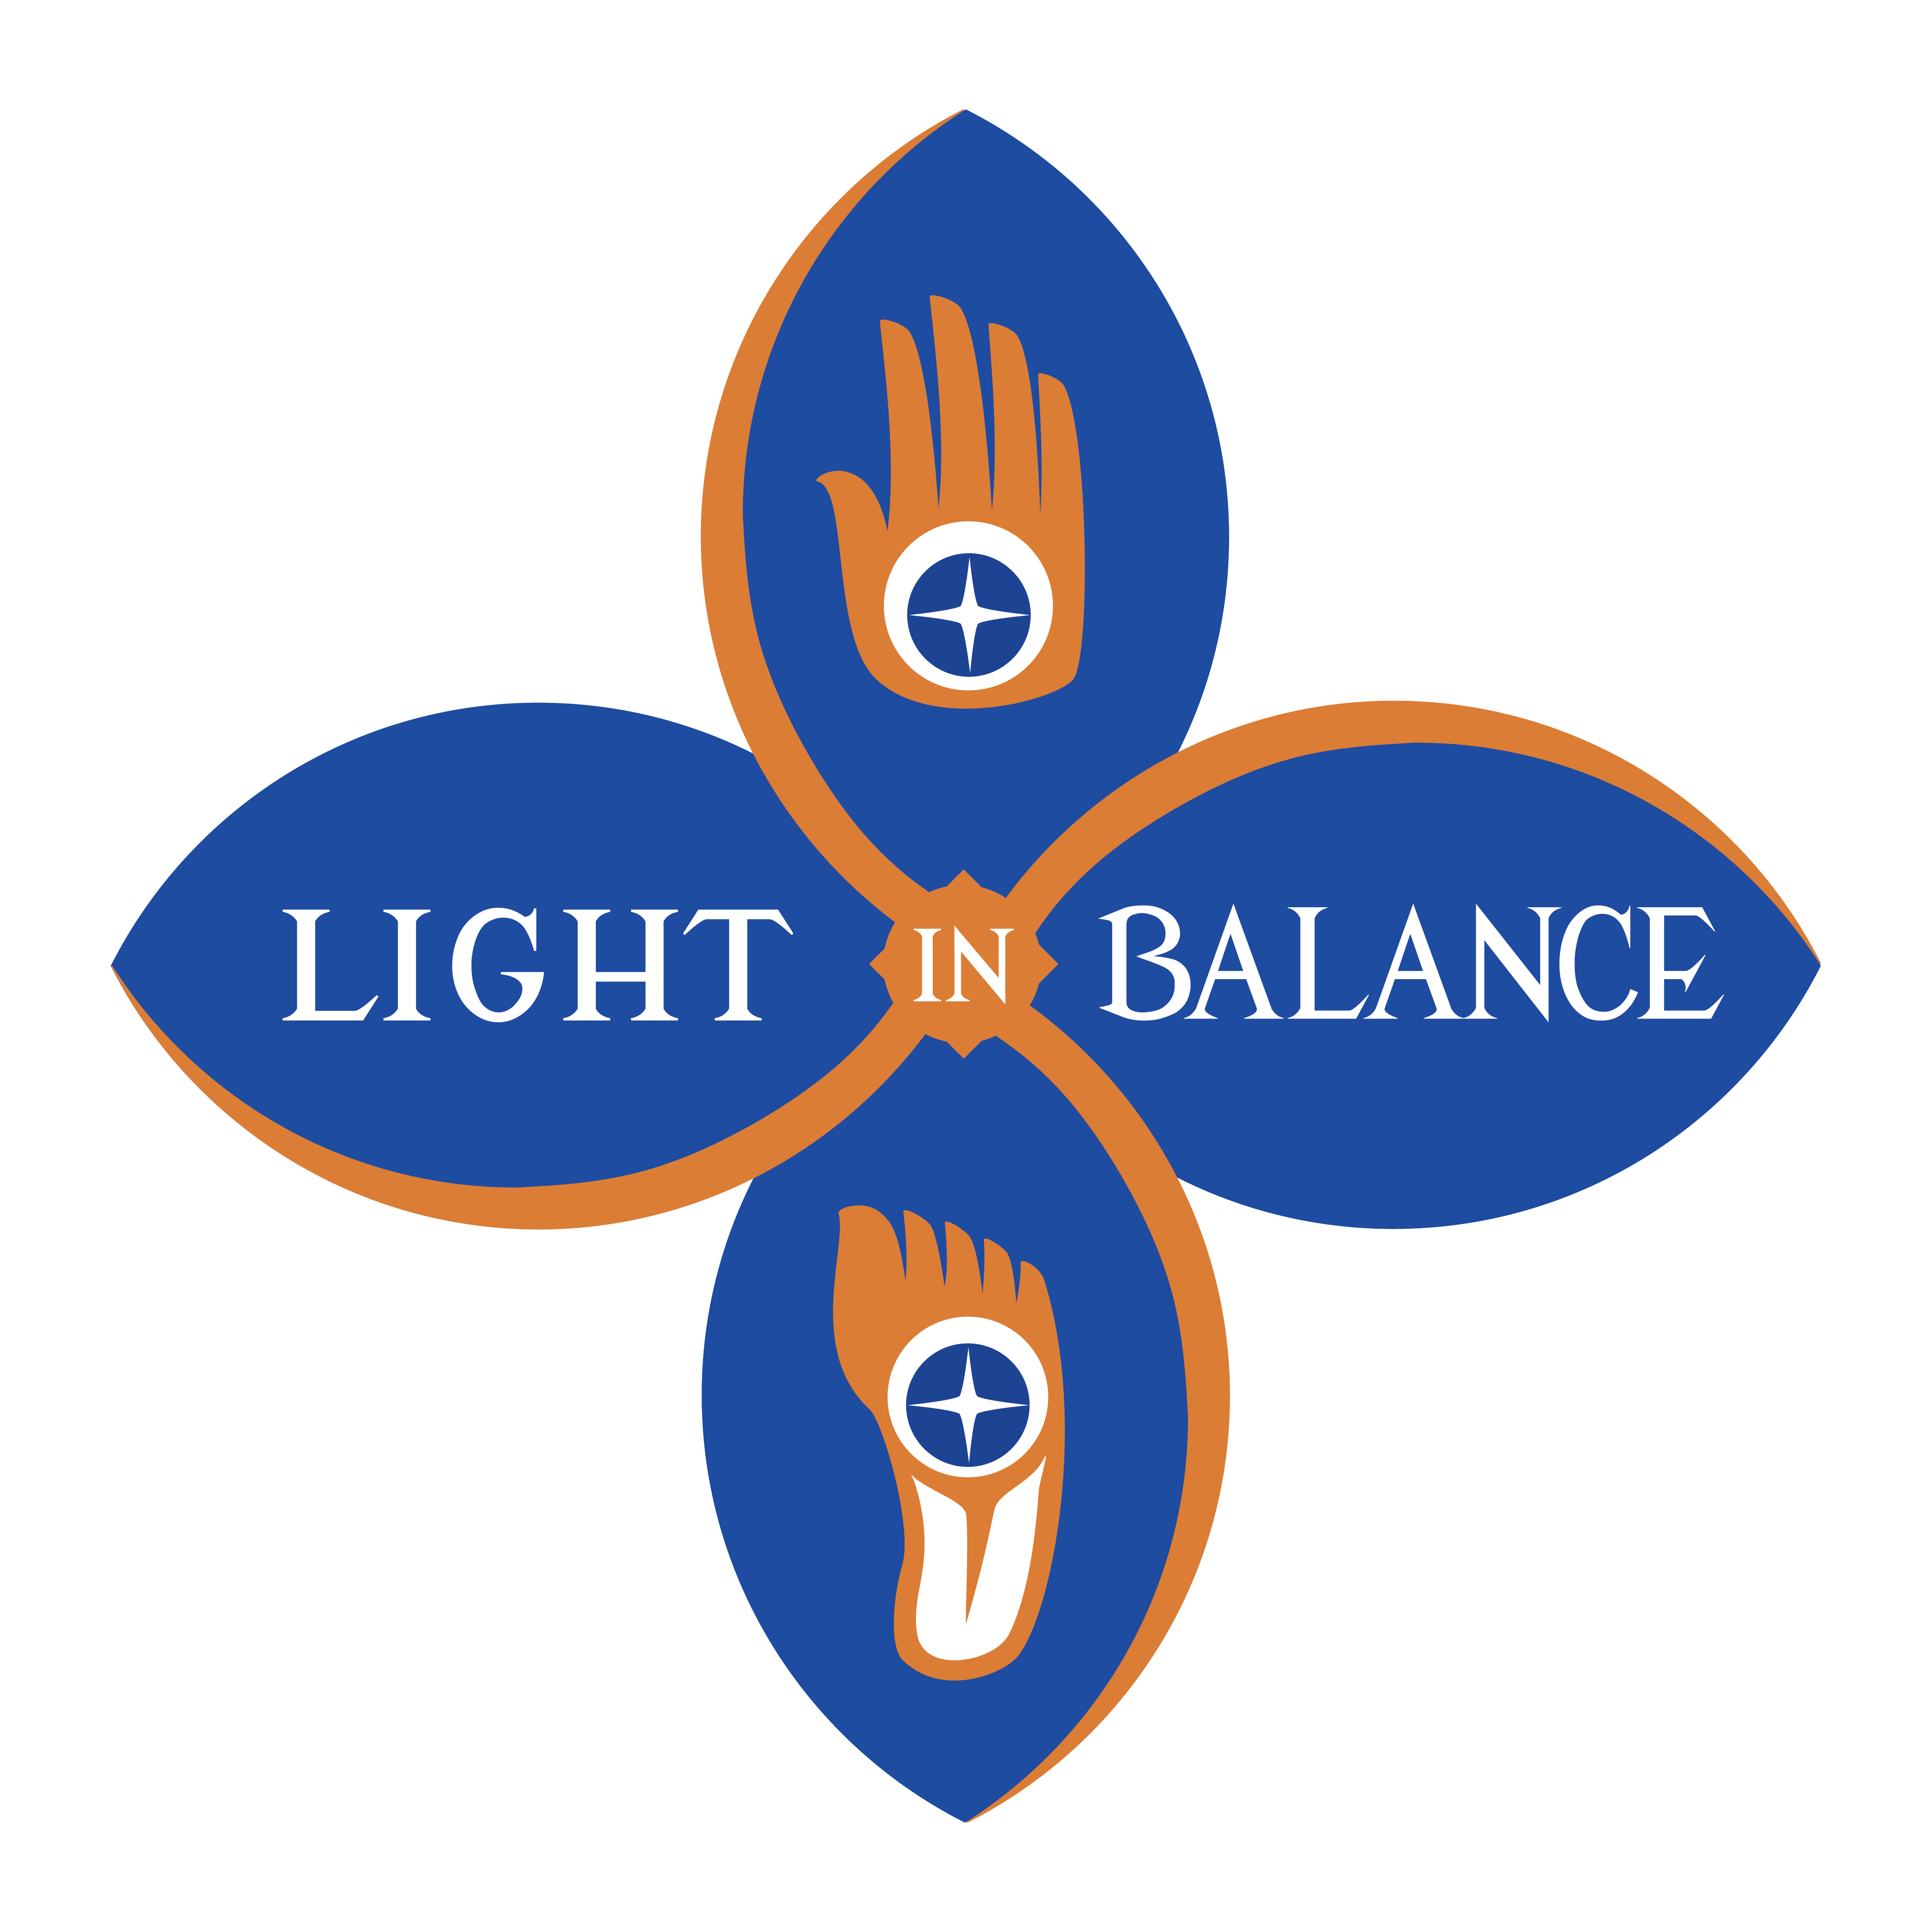

Intake Form
Name:__________________ Date of birth:_________ Address:___________________________________ City, State, Zip_______________________________ Cell Phone:______________ Home Phone:__________ Email:_____________________________________
How did you hear about me? _________________________________________
1.) Have you had Reflexology before? Yes / No
2.) Have you had energy healing before? Yes / No
3.) What is your primary goal for today’s session? _________________________________________ ________________________________________________________________________________
4.) Major Illnesses (Current and Past):____________________________________________________________________________
5.) Are you currently under a doctor’s care? Yes / No ~If Yes, why?__________________________________
6.) PastSurgeries:_________________________________________________________________
7.) Medications you are using:________________________________________________________
8.) Are you Pregnant? Yes / No Trying? Yes / No
9.) How would you rate your overall health? Excellent Good Fair Poor
10.) Are you having any problems with your feet? Yes / No If yes, what kind(s): _________________________________________
11.) Where is the tension most evident in your body?_____________________________________

Disclaimer Form

What you need to know: I am not a medical doctor
- I do not practice medicine
- I do not diagnose illnesses
- I do not prescribe or adjust medication
What is Reflexology?

Reflexology is a form of bodywork based on the ancient art and modern science of rhythmically applying thumb and finger pressure to specific reflex points on the feet, hands and ears to facilitate the natural healing process of the body. Reflexology clears energetic pathways, improves circulation and reduces and/or eliminates the biomechanical and physiological symptoms of negative stress that can be seen and felt in the body, mind and spirit. Recipients of regular reflexology report a significant reduction and/or elimination of symptoms associated with negative stress.

What is Reiki?
Reiki is a simple, natural and safe method of hands on spiritual healing, where hands are placed on or just above the client’s body. It is also a form of self-improvement that everyone can use; and has been effective in helping virtually every known illness and malady and always creates a beneficial effect. It also works in conjunction with all other medical or therapeutic techniques to relieve side effects and promote recovery.

What do they do?
Healing is a fascinating process which is generally very poorly understood. Although it may be tempting to believe that we can heal other people, it is of utmost importance to realize that all healing is self-healing. The body has an extraordinary intelligence and ability to heal itself and reflexology and energy healing are tools for awakening this intelligence for the body to self-heal!
By signing this form, I give my consent to this reflexology or energy healing session. I understand that I may discontinue a session at any time. If I have been diagnosed by a licensed health professional as having any disease, injury, or other physical or mental condition I understand that I should inform the person who made the diagnosis about the sessions I am having, and whether or not I intend to discontinue any treatment or therapy which has been previously ordered, prescribed or recommended by the licensed health professional. I understand that by discontinuing any such treatment or therapy, I assume responsibility for any negative outcome resulting from discontinuing that treatment or therapy.
Client’s Signature:__________________________________Date:__________ Printed Name________________ _

